Westfield School Junior House
Curriculum Information for Transition class
Autumn Term 2021

Mathematics | This term we will be covering place value to 20 in our number work. We will be ordering and representing the numbers to 20, comparing the numbers and groups of numbers, counting forwards and backwards, using the greater than and less than signs and recognising tens and ones.  The part-whole model will be introduced in our addition and subtraction work. We will be concentrating on addition bond, systematic methods for number bonds to 10 and 20, adding together, adding more and fact families. We will be subtracting by crossing out and counting back and comparing addition and subtraction statements.  We will be learning about 2D and 3D shapes, sorting them according to their basic properties and learning their names. We will be pattern making, using the shapes.  We will be having lots of fun with our maths activities and will be doing lots of practical activities using the equipment and playing games. We will be taking some of our maths lessons outdoors too.
English | We will be continuing the structured phonics programme and practising on a daily basis. Key words will be learned by sight to help with reading and writing. Correct letter formation will be revised and also practised regularly using lower case and uppercase letters.  Independent writing will be encouraged through a range of stimuli, starting with short basic sentences this term. We will be focussing on the use of finger spaces, capital letters at the beginning of sentences and proper nouns and the use of full stops. Nouns and adjectives will be covered and also the use of question marks.  A range of literature will be studied and we will discuss fiction and non-fiction. We will be discussing characters in stories, settings and story structures. Grammar and spelling within the stories will be explored and we will look at rhyming words and also some poetry.  The girls will be reading aloud at school daily and I would ask that you continue to hear your daughter read each evening, discussing the text, asking questions about its content, expressing opinions and making predictions.
Science | In Science we will be learning about different parts of the body and exploring our five senses. We will also be learning about the different stages of the human lifecycle. We will be observing seasonal changes throughout the term and this will continue throughout the year in Transition.
Geography   | - Explore different types of homes found in the UK and explore homes around the world.  - Geographical vocabulary related to towns and countryside.  - Look at basic maps and their features, use of symbols.
History  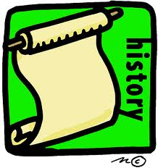 | Houses and Homes  We will be looking at different buildings around us, new and old, and different types of homes through the ages.  Remembrance Day  - Learn about the origins of Remembrance Day and its role today.  - Explore why we remember events.
Computing | - Internet safety  - Programming with Bee bots  - Digital painting  - Introduction to Animation
R.E. | - We will be learning about the Jewish faith, some of the festivals they celebrate and about the importance of the Torah to the Jewish people.  - The Christmas Story
Art  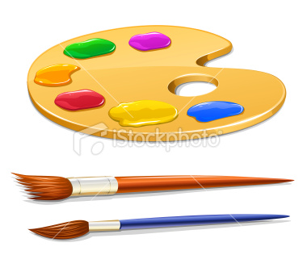 | Bodies  - Make different bodies shapes, model and draw each other  - Skulls – decorate with pattern and colour  - Face collages – use magazine and newspaper images  - Opie style portraits  - Clothes peg figures  Colour  - Learn about primary and make secondary colours  - The colour wheel  - Learn to make light and dark shades  - Look at different artists who use colour – Kandinsky, Mondrian
Technology  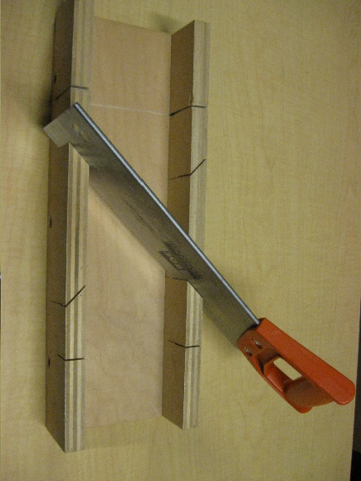 | Homes  Become a budding architect. Study houses around the world looking at their shapes and features. Explore ways to combine and join different shapes and materials. Study the interior of different houses.  Puppets  - Design and make a hand puppet
French | - Learn different greetings, saying your name  - Explore the topic Autumn  - Learn classroom instructions and simple action words  - Explore and improve recall of numbers 1-20
PE  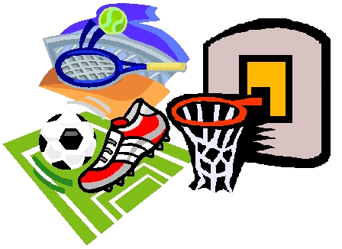 | - Movement skills – walking, jogging, running, changing speed and changing direction, jumping, hopping, skipping with a rope/hoop / without a rope, side stepping, combining movement patterns.  - Spatial awareness – moving safely in defined spaces, awareness of others/equipment and moving accordingly  - Ball skills – throwing, catching, rolling, kicking, hitting, aiming at a target both individually and with a partner/ group. working cooperatively to use skills as a team. Team games/ small-sided competitive games.  - Dance – following a sequence of moves, creating own moves, responding to stimuli such as music, pictures or themes.  - Yoga – following poses and moves, linking moves together, developing focus, concentration and reflection.  - Gymnastics – rolling, balancing. movement, linking moves together to create short sequences. Use of equipment.
Music   | Family events  Composition and performance work based on:  - Birthdays  - Halloween  - Bonfire Night  - Christmas

